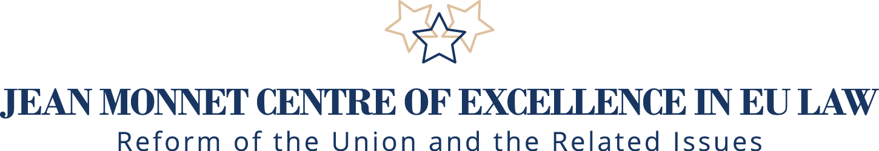

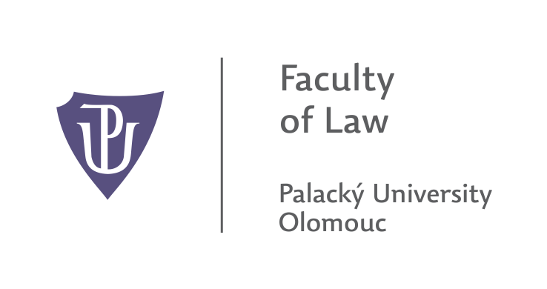

 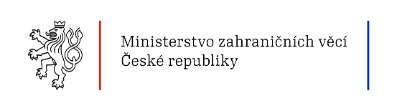

**Jean Monnet International Scientific Conference**

**22. 5. – 23. 5. 2017**

**The EU in time of multicrisis and its greatest challenges – up-to-date solutions, future visions and prospects**

**Venue: Czech Republic, Prague, Ministry of Foreign Affairs of the Czech Republic – (Czernin Palace, the Grand Hall Loreta Square 5, Prague 1, 118 00)**

**22. 5. (Monday) First day of the Conference**

**10:30 – 11:00 Plenary session**

**Opening:**

* **10:30 – 10:40** Assoc. Prof. et. Assoc. prof. JUDr. **Naděžda Šišková**, Ph.D. (Head of Jean Monnet Centre of Excellence in EU Law, Faculty of Law, Palacky University, President of the Czech Association for European Studies – Czech ECSA)

**Welcome adress:**

* **10:40 – 10:50** Ing. **Ivo Šrámek** (Deputy Minister of Foreign Affairs for Security and Multilateral Issues)

**Keynote speech:**

* **10:50 – 11:10** Mgr. et Mgr. **Věra Jourová**, Member of the European Commission, (Justice, Consumers & Gender Equality)

***"Achievements and Challenges of the EU, possible paths for the future”***

* **11:10 – 11:25** **Vito Borrelli** (Head of Sector Jean Monnet & China Desk, European Commission – DG EAC)

***"The future of Europe: a commitment for You(th) – the main outcomes of the Jean Monnet Seminar held in Rome"***

**11:25 – 11:40 Coffee break**

**Section 1 European Union and its democratic foundations in time of multicrisis. The most effective ways of European governance and reform of the EU institutions.**

* **Chair:** Prof. **Marc Maresceau** (Jean Monnet Chair ad personam, University of Ghent; Visiting Professor College of Europe Bruges and Natolin)
* **11:40 – 11:55** prof. Dr. Dr. h.c. mult. **Peter-Christian Müller-Graff** (Director of Institute for European Law, University of Heidelberg, Jean Monnet Chairholder, President of German ECSA)

***“The Authority of European Union Law in Rough Political Times”***

* **11:55 – 12:10** Prof. **Miguel Poiares Maduro** (Professor of law at the European University Insitute, Florence)

***“The EU Crisis and the Crisis of National Democracies”***

* **12:10 – 12:25** Assoc. Prof. et. Assoc. Prof. JUDr. **Naděžda Šišková**, Ph.D. (Head of Jean Monnet Centre of Excellence in EU Law, Faculty of Law, Palacky University, President of the Czech Association for European Studies – Czech ECSA)

***“Political procedure under article 7 TEU – test of its effectivity and future prospects”***

* **12:25 – 12:40** Mag. **Roman Puff** (Senior scientist at University of Salzburg, ECSA Austria)

***“The Role of Courts in Multilevel Polities – the Example US Courts Balancing Values and Sovereignity from Prigg i.e. Prigg v. Pennsylvania, 41 U.S. (16 Pet.) 539 (1842)] to Dennison [i.e. Kentucky v. Dennison, 65 U.S. (24 How.) 66 (1861)]”***

* **12:40 – 12:55 Discussion**

**13:00 – 14:00 Lunch**

**Section 2 Brexit and its implications**

**Chair:** Prof. Ing. **Lubor Lacina**, Ph.D (Jean Monnet Chair in European Economic Studies, think-tank Mendel European Centre, director Jean Monnet Centre of Excellence, Mendel University, Brno)

* **14:00 – 14:15** Prof. **Takis Tridimas** (Chair of European Law, Director,Centre of European Law, Dickson Poon School of Law, King´s College London)

***“Citizens and Sovereigns in the Brexit Bargain: What does it mean to belong”***

* **14:15 – 14:30** Prof. Dr. Dres. H. C. EM. **Rainer Arnold** (Emeritus Professor of Public Law, University of Regensburg, Jean-Monnet-Chair ad personam for European Law)

***“Brexit and UK constitutional law: Some critical reflections”***

* **14:30 – 14:45** Assoc. Prof. **Lenka Pítrová**, CSc. (Faculty of Law, Charles University in Prague)

***“Brexit and Institutional Changes – Challenge or Threat (Czech Perspective)”***

* **14:45 – 15:00 Discussion**

**Section 3 Actual challenges in the EU area of freedom, security and justice.**

**Chair:** Assoc. prof. et. Assoc. prof. JUDr. **Naděžda Šišková**, Ph.D. (Head of Jean Monnet Centre of Excellence in EU Law, Faculty of Law, Palacky University, President of the Czech Association for European Studies – Czech ECSA)

* **15:00 – 15:15** Prof. Dr. Dr. **Jörg Monar**, Ph.D. (Rector of College of Europe, Bruges)

***“The area of freedom, security and justice as a constitutional objective: Is the EU delivering?”***

* **15:15 – 15:30** Assoc. Prof. Dr. iur. **Harald Christian Scheu**, Mag. phil., Ph.D. (Faculty of Law, Charles University in Prague)

***“Migrant Integration as an EU Agenda"***

* **15:30 – 15:45 Discussion**

**15:45 – 16:00 Coffee break**

**Section 4 Reflection of current challenges for the EU in the field of the external relations.**

**Chair: doc. Ing. Lenka Fojtíková, Ph.D. (Faculty of Economics, Technical Univerzity Ostrava)**

* **16:00 – 16:15** Prof. **Marc Maresceau** (Jean Monnet Chair ad personam, University of Ghent; Visiting Professor College of Europe Bruges and Natolin)

***“The legal framework of the relations of the EU with its European Neighbours (with special attention on relations EU – Turkey)”***

* **16:15 – 16:30** Ing. **Ivo Šrámek** (Deputy Minister of Foreign Affairs for Security and Multilateral Issues)

***“Current challenges in external relations and European security"***

* **16:30 – 16:45** Univ.-Prof. Dr. **Werner Schroeder,** LL.M. (Head of the Institute, Institute for European and international law, University of Innsbruck)

***“Democratic Control of Free Trade Agreements of the EU: The Case of CETA”***

* **16:45 – 17:00** Prof. **Viktor I. Muraviov** (Head of Chair of Comparative and European Law at Taras Schevchenko Natinal University in Kiev)

***“European intergation and europeazation of Ukrainian legislation“***

* **17:00 – 17:15** Prof. Ing. **Eva Cihelková**, CSc. – MSc. **Hung Phuoc Nguyen** (professor and PhD. Student at the Faculty of Economics and Business, Pan-European University in Bratislava, Slovakia)

***“European Union – China Comprehensive Strategic Partnership: How to understand the concept and its responses to current challenges?”***

* **17:15 – 17:30 Discussion**

**18:00 – 19:00 Dinner**

**23. 5. (Tuesday) Second day of the Conference**

**Section 5 Eurozone and its challenges.**

**Chair:** Prof. Ing. **Lubor Lacina**, Ph.D (Jean Monnet Chair in European Economic Studies, think-tank Mendel European Centre, director Jean Monnet Centre of Excellence, Mendel University, Brno)

* **10:00 – 10:15** Prof. **Tibor Palankai** (Corvinus University, Budapest, LCF-member)

***“Rethinking Integration Theory (in light of present crisis)”***

* **10:15 – 10:30** Prof. Ing. **Lubor Lacina**, Ph.D (Jean Monnet Chair in European Economic Studies, think-tank Mendel European Centre, director Jean Monnet Centre of Excellence, Mendel University, Brno)

***“Restoring the Economic Growth and the Real Convergence in the Eurozone”***

* **10:30 – 10:45** JUDr. **Jiří Georgiev,** Ph.D. (Director of the Department of the Property Settlement, Ministry of Agriculture of the Czech Republic).

***“the OMT programme under ultra vires review”***

* **10:45 – 11:00 Discussion**

**11:00 – 11:15 Coffee break**

**Section 6 Future visions and prospects how to change the EU**

**Chair:** JUDr. **Ondrej Hamulák**, Ph.D., Member of Jean Monnet Centre of Excellence in EU Law, Faculty of Law, Palacky University in Olomouc, Member of Jean Monnet Centre of Excellence in EU Law

* **11:15 – 11:30** Mgr. **David Král** (Director of Policy Planning Department, Ministry of Foreign Affairs of the Czech Republic)

***"The White Paper on the Future of Europe in the Context of Ensuing Brexit and Other Challenges - a Czech Perspective"***

* **11:30 – 11:45** JUDr. **David Petrlík,** Ph.D. (Senior Legal Officer, European GNSS Agency)

***“Intergovernmentalism as a response to EU challanges: threat or solution”***

* **11:45 – 12:00 Discussion**

**12:00 – 13:00 Lunch**

**13:00 Ending of the Conference**

Working language of the Conference is English, interpretation will not be provided.

**Scientific and Organization Committee:**

**Head of the Committee:**

Assoc. Prof. et. Assoc. Prof. JUDr. **Naděžda Šišková**, Ph.D., Head of Jean Monnet Centre of Excellence in EU Law, Faculty of Law, Palacky University in Olomouc,

**Members of the Committee:**

Prof. **Marc Maresceau**, Jean Monnet Chair ad personam, University of Ghent, Ghent European Law Institute; Visiting Professor College of Europe Bruges and Natolin

JUDr. **Kristýna Najmanová,** LL.M., Director – EU Law Departement, Ministry of Foreign Affairs of the Czech Republic

Prof. Ing. **Eva Cihelková**, CSc., Faculty of Economics and Business, Paneuropean University in Bratislava, Slovakia, Vice-President of the Czech Association for European Studies – Czech ECSA

Assoc. Prof. JUDr. **Blanka Vítová**, Ph.D., LL.M., Vice-Dean at Faculty of Law, Palacky University in Olomouc, Member of Jean Monnet Centre of Excellence in EU Law

JUDr. **Ondrej Hamulák**, Ph.D., Member of Jean Monnet Centre of Excellence in EU Law, Faculty of Law, Palacky University in Olomouc, Member of Jean Monnet Centre of Excellence in EU Law

JUDr. **Michal Petr**, Ph.D., Member of Jean Monnet Centre of Excellence in EU Law, Faculty of Law, Palacky University in Olomouc,

Mgr. **Lucie Dvořáková,** LL.M., EU Law Departement, Ministry of Foreign Affairs of the Czech Republic